Samantha Spadaro
Professor Dong
BFIN515
October 5, 2026
When Restaurants Raise Prices, How Much Less Do Customers Eat Out?
1. Business Question
Restaurant operators have faced higher labor and food costs, leading many to raise their menu prices. Since 1992, menu prices have gone up about 18 percent more than overall prices, while grocery prices have stayed close to inflation (−1.6 percent relative change; see Figure 1). This leads to a key question for the industry: what matters most? When menu prices go up, how much do customers cut back, and do they start cooking at home instead? Operators need to know how much of their cost increases they can pass on. Investors want to know if sales growth from higher prices will last. Policymakers need to understand how wage mandates affect consumers and restaurant demand.
Earlier research shows that demand is somewhat responsive to price changes. One U.S. study found that eating out is one of the most price-sensitive food categories, with elasticities around 0.7 to 0.8 in absolute value (Andreyeva, Long and Brownell, 2010). Okrent and Alston (2012) found that full-service restaurants react more to price changes than fast-food places. On the cost side, Aaronson, French, and MacDonald (2008) found that restaurant prices go up when minimum wages rise. Many of these estimates are over ten years old, and since then, menu prices have increased a lot.
This paper follows Dong (2026), who groups supply and demand estimation methods based on the data available. The data used here are national totals: restaurant sales, menu and grocery prices, income, and restaurant costs, without details on individual restaurants or customers. Dong explains that with this kind of aggregate data, you need instruments to separate demand from supply, so this paper uses changes in restaurant costs for that. He also says the best way to test a demand estimate is to see how well it predicts a new period, which is covered in Section 5.
2. Data
The data are monthly and come from the Federal Reserve Bank of St. Louis economic database, FRED (Federal Reserve Bank of St. Louis, 2026). Restaurant sales come from the Census Bureau’s monthly survey of restaurants and bars (U.S. Census Bureau, 2026). Menu and grocery prices come from the Bureau of Labor Statistics Consumer Price Index, which tracks what people pay for restaurant and grocery food (U.S. Bureau of Labor Statistics, 2026). Household income is inflation-adjusted disposable income from the Bureau of Economic Analysis. Restaurant costs are measured by average hourly pay for workers in restaurants and hotels, and the producer price index for processed food, which tracks what restaurants pay suppliers.
Real restaurant spending is measured by dividing sales by the menu-price index. This shows how much food and drink customers actually buy, not just how much they spend. Menu prices, grocery prices, wages, and food costs are all divided by the overall CPI to show prices compared to everything else people buy. The data run from January 1992 to August 2026, with the first 12-month change in January 1993. Data from March 2020 to June 2021 are left out because in April 2020, restaurant sales dropped 51 percent from the year before due to closures, not price changes.
3. Method
Relative menu prices have gone up slowly and steadily for decades. In the raw data, prices change very slowly, and estimates depend heavily on how you model the trend. The main model uses 12-month changes, comparing each month to the same month a year before, which helps remove trends and seasonal effects. The model then estimates yearly changes in real restaurant spending based on yearly changes in menu prices, grocery prices, and household income.
This approach gives us three key numbers. Menu-price elasticity shows how restaurant spending changes when menu prices rise or fall, which is the paper's main focus. Grocery-price (cross-price) elasticity shows if people eat out more or less when grocery prices change. If this number is positive, it means people eat out more when groceries get more expensive. Income elasticity shows how restaurant spending changes when household income changes.
Ordinary least squares (OLS) can give misleading results because restaurants often raise prices when demand is strong, and mistakes in the menu-price index can affect both spending and prices at the same time. To fix this, we use two-stage least squares, using two cost shifters as instruments to adjust menu prices. These instruments work well: in the first stage, a 10 percent increase in real wages leads to menu prices about 5.1 percent higher, and the first-stage F-statistic is 23, which is well above the usual cutoff of 10. We use Newey-West standard errors to handle correlation between overlapping 12-month changes. We coded the estimators in Python and tested them on simulated data with known results.
4. Results
Table 1 shows the main results for 1993 to 2026 (376 months). In the preferred IV model, which uses both cost shifters as instruments, the menu-price elasticity is −0.76 (standard error 0.31). This means a 10 percent increase in real menu prices leads to about a 7 percent drop in real restaurant spending. Demand is inelastic, but not by much, so raising prices increases revenue but also loses a noticeable number of customers. The estimate changes very little depending on which instruments are used (−0.81 with wages only, −0.54 with food costs only, though the latter is less precise) and is close to the OLS result (−0.86).
The cross-price elasticity with groceries is 0.14 and not statistically significant. When grocery prices rise, customers do not noticeably shift their spending to restaurants, so the national data do not show strong substitution between eating out and cooking at home. The drop in restaurant spending seems to come mostly from people eating out less often or spending less each time. The income elasticity is 0.25, which is positive and somewhat significant, meaning eating out tends to increase as household income rises.
5. Validation
Looking at different time periods, I re-estimated the model on separate samples. The elasticity is −0.85 for 1993–2007 and −0.55 for 2008–2019, but this difference is not statistically significant (z = −0.51). The pre-pandemic sample alone gives −0.78, which is almost the same as the full sample. The post-COVID-19 period cannot be estimated reliably because, over those four years, the cost shifters barely changed compared to prices (first-stage F = 1.0), so the main estimate relies on a longer history. Rolling 10-year windows range from −1.66 to 0.20, showing that a decade of data is not enough for a precise estimate and that the full sample is needed.
Other specifications. Alternative versions show that 6-month changes give −0.58, a slightly smaller short-horizon response. Models in levels confirm the earlier warning about trends: with a time trend the IV elasticity is −1.08, and a dynamic version implies a long-run elasticity of −1.64, while without a trend it collapses to −0.17. Because the levels answer depends on an arbitrary trend choice, the differenced model is preferred. Apart from the dynamic long-run and no-trend levels models, every specification tested puts elasticity between about −0.54 and −1.08, with −0.76 in the middle.
For out-of-sample testing, I trained the model on data from 1993 to 2019 and predicted 12-month spending growth from July 2022 to August 2026 using actual price and income changes. The price model had an error of 3.00 percentage points, which is lower than the income-only model (3.81) and the constant-growth benchmark (3.25). The model’s strength shows up in 2023–2024, when sharp menu inflation was followed by flat or falling real restaurant spending, something a model that ignores prices cannot explain. This kind of out-of-sample test is what Dong (2026) calls the best evidence for a demand estimate.
As a benchmark, the estimate of −0.76 is within the 0.7–0.8 range (in absolute value) reported by Andreyeva, Long and Brownell (2010), though this study uses newer data and a different method.
6. Recommendation
To put these estimates in dollar terms, the calculation uses the last 12 months of sales, which total about $1.06 trillion.
Restaurant operators can pass on higher costs, but they will lose some customers. If menu prices go up 5 percent across the industry, real spending drops by about 3.6 percent, and sales increase only about 1.2 percent. Fewer sales offset most of the price increase, so controlling costs and planning menus matter as much as pricing. This elasticity applies to the whole industry; if one restaurant raises prices while others do not, it will lose even more customers. Operators should raise prices along with the market, not before it.
Investors should watch for sales growth driven by higher menu prices. While higher prices boost reported sales in the short term, with an elasticity near −0.76, every point of price growth costs about three-quarters of a point in customer traffic. The years 2023–2024 show how quickly real spending can slow down after fast price increases.
Policymakers considering higher minimum wages should expect some of the cost to be passed on to customers. The estimates suggest that a 10 percent increase in real restaurant wages leads to menu prices about 5.1 percent higher and real restaurant spending about 3.7 percent lower, which matches the findings of Aaronson, French and MacDonald (2008). However, this link should not be seen as an exact pass-through rate, since wages also respond to restaurant demand.
This analysis has some limitations. It uses national averages, so it cannot separate full-service from fast-food restaurants, which Okrent and Alston (2012) show react differently. Wages may also respond to restaurant demand, which could weaken the instrument, but the similar estimate using food costs alone suggests this is not a major issue. The post-COVID period is too short to estimate on its own. Finally, as Dong (2026) points out, demand estimates work best for prices and conditions similar to those in the data, so these results are most reliable for price changes like those since 1993.
All data and code for this paper are available on GitHub: https://github.com/[your-github-username]/restaurant-demand-elasticity

References
Aaronson, D., French, E., and MacDonald, J. (2008). The minimum wage, restaurant prices, and labor market structure. Journal of Human Resources, 43(3), 688–720. https://jhr.uwpress.org/content/43/3/688
Andreyeva, T., Long, M. W., and Brownell, K. D. (2010). The impact of food prices on consumption: A systematic review of research on the price elasticity of demand for food. American Journal of Public Health, 100(2), 216–222 https://pubmed.ncbi.nlm.nih.gov/20019319/
Dong, T. (2026). Supply and demand functions: A survey by data availability. SSRN Working Paper No. 7399858. https://papers.ssrn.com/sol3/papers.cfm?abstract_id=7399858
Federal Reserve Bank of St. Louis (2026). FRED Economic Data: restaurant sales, consumer and producer price indexes, disposable income, and leisure and hospitality earnings. Retrieved October 2, 2026, from https://fred.stlouisfed.org
Okrent, A. M., and Alston, J. M. (2012). The demand for disaggregated food-away-from-home and food-at-home products in the United States (Economic Research Report No. 139). U.S. Department of Agriculture, Economic Research Service. https://www.ers.usda.gov/publications/pub-details?pubid=45006
U.S. Bureau of Labor Statistics (2026). Consumer Price Index; Current Employment Statistics; Producer Price Index. https://www.bls.gov
U.S. Census Bureau (2026). Advance Monthly Retail Trade Survey: Food services and drinking places. https://www.census.gov/retail
AI disclosure: I used Claude (Anthropic) to write the analysis code and outline this paper; I chose the topic, collected the data, and reviewed the final version.
Table 1. Restaurant demand elasticities (12-month changes)
 | (1)  OLS | (2)  IV: wages +  food PPI | (3)  IV: wages  only | (4)  IV: food PPI  only
Menu-price elasticity | −0.857***  (0.251) | −0.758**  (0.313) | −0.810***  (0.297) | −0.543  (0.562)
Grocery-price (cross) elasticity | 0.161  (0.165) | 0.137  (0.177) | 0.150  (0.174) | 0.085  (0.216)
Income elasticity | 0.256*  (0.133) | 0.250*  (0.141) | 0.253*  (0.140) | 0.236  (0.152)
First-stage F |  | 23.1 | 32.0 | 10.9
Months | 376 | 376 | 376 | 376
Dependent variable: 12-month log change in real restaurant spending. Regressors: 12-month log changes in the relative menu price, relative grocery price, and real disposable income, plus a constant. Column 2 is the preferred model. IV columns instrument the menu price with the listed cost shifters. Newey-West standard errors in parentheses. *** p<0.01, ** p<0.05, * p<0.10.
Figure 1. Real menu and grocery prices, and real restaurant spending, 1992–2026
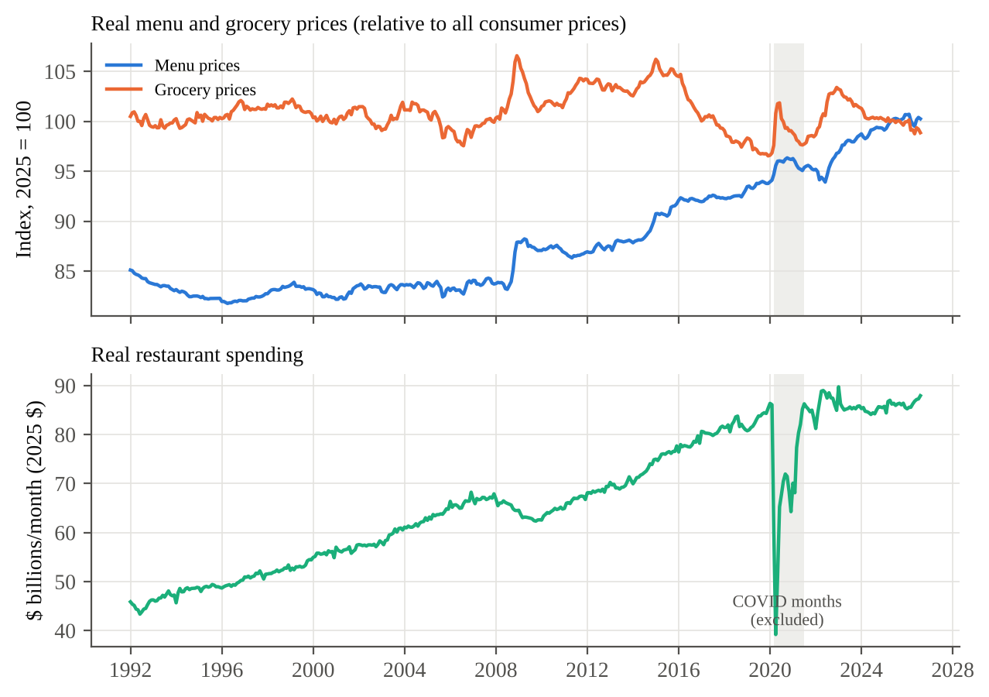
Source: FRED (Census Bureau, Bureau of Labor Statistics). Prices are shown relative to the overall consumer price index, indexed so that 2025 = 100. Shaded months (March 2020–June 2021) are excluded from the analysis.

